Clock Controller Software
Version 1.0
© 2014-2016 Josh Lange
http://bitbucket.org/macman88/
Table of Contents
Introduction 3
Prerequisites 3
Starting 3
Time Settings 5
Set Time 5
Set Clock Offset 5
Schedule Settings 6
Entering Schedule 6
Clearing Schedule 6
Clear Entire Schedule 6
Clear Single Column 7
Save Schedule 7
Load Schedule 7
Download Schedule 7
Upload Schedule 7
Advanced 7
System Number 7
Bell Length 8
Enabling/Disabling Bells 8
Ring Bells 8
Other 8
Troubleshooting 8

Introduction
The Clock Controller software ties in to your master clock system, allowing you to set the time and edit the bell schedule remotely with an easy to use interface.

Prerequisites
In order to run the clock controller software, you will need to have Java installed. (Version 7 or later recommended). If the application opens when you double click the Clock_Controller.jar file, you should be all set. Otherwise, download and install the latest version of Java from http://javadl.sun.com/webapps/download/AutoDL?BundleId=101406. Be sure to uncheck the two offers from ask.com or Yahoo, or whoever they’re bundling this week when installing Java.
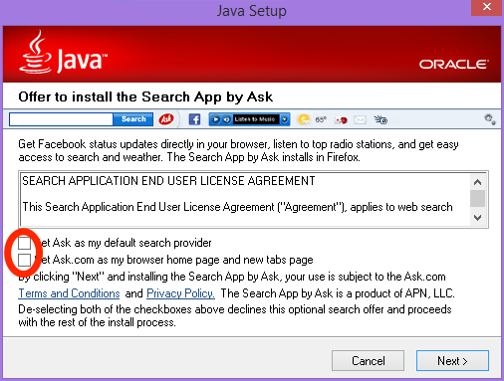

Starting
Double-click the Clock_Controller.jar file to open the application. The following screen will appear.
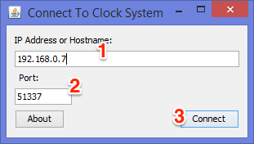
Enter the provided IP address (1) and port number (2) and click connect (3). If the application is able to connect to the clock, you will proceed to the next screen. Otherwise, you will see an error message. If are not able to connect, make sure that you correctly entered the IP Address and port number, and that your computer is connected to the right network.
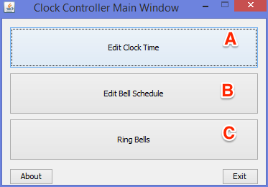

Time Settings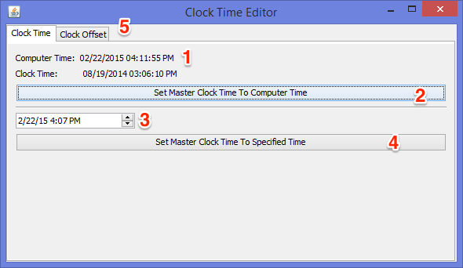

Set Time
Click on the “Edit Clock Time” button (A) in the main window. The Clock Time Editor window will appear. The top line of the window (1) will display the current time on your computer's clock. To set the master clock system to this time, Click on the “Set Master Clock Time To Computer Time” button (2). The master clock will immediately be set to the computer's time, and the wall clocks should start moving to reflect the new time (unless the wall clocks are already within a few minutes of the set time). If for some reason your computer's clock is wrong, or you wish to set the master clock to a different time, you can enter the desired time and date in the provided field (3) and press the “Set Master Clock To Specified Time” button (4).

Set Clock Offset
In normal operation of the clock system, you should never have to touch this. However, if you know that you need to adjust the clock offsets, read on.
The proper operation of the clock system requires that the clock system know what time the wall clocks are reading. If, for some reason, the wall clocks are reading a different time than the system expects, strange results may occur.
To set the clock offsets, Click on the “Edit Clock Time” button (A) in the main window. Then click on the “Clock Offset” tab (5) at the top of the window. The line “Clock System 1 Offset” and “Clock System 2 Offset” will display the current time that the system believes should be displayed on the wall clocks. (Currently, only system 1 is in use.) If the displayed offset doesn't match the current time displayed by the wall clocks, use the controls to enter the currently displayed time, and press update.

Schedule Settings
To access the schedule settings window, Click on the “Edit Bell Schedule” button (B) in the main window. The Bell Schedule Editor window will open.
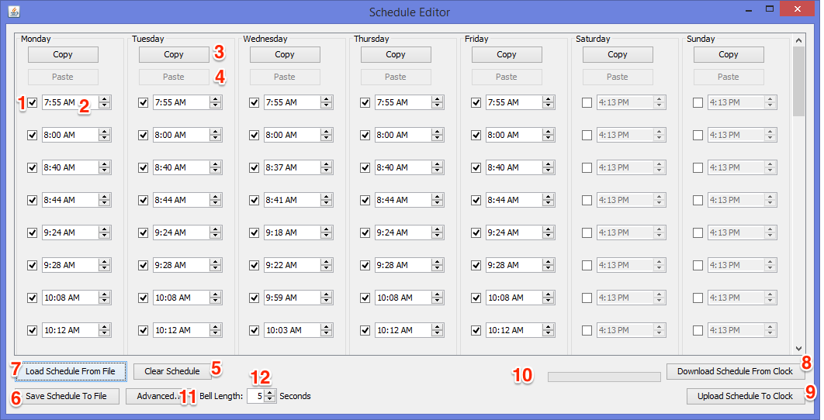

Entering Schedule
The schedule editor window displays 7 columns, one for each day of the week. Up to 40 bell times can be entered for each day. A checkmark to the left of each bell time indicates that that time is enabled. Bell times that are not enabled will not be saved or uploaded to the clock system. To add a time, click the checkmark (1) and set the desired bell time using the time control (2). Times do not necessarily need to be entered in chronological order; they will be automatically sorted by the clock system once uploaded.
After one column has been entered, it can be copied to other columns using the copy (3) and paste (4) buttons above each column.

Clearing Schedule

Clear Entire Schedule
Press the “Clear Schedule” button (5) to clear the entire schedule. You will be asked if this is something you really want to do. Be careful, as there is no undo if you clear the schedule without saving it.

Clear Single Column
To clear any single column of the schedule, click copy in any column, then hold down the shift key and press the paste button (4) in the column you wish to clear.

Save Schedule
After entering or downloading a schedule, it can be saved for future use. Click the “Save Schedule To File” button (6) to save the current schedule to a file.

Load Schedule
To load a previously saved schedule, click on the “Load Schedule From File” button (7). Note that loading a schedule from a file will erase the currently displayed schedule. If you don't want to lose the currently displayed schedule, be sure save it first.

Download Schedule
To download the schedule that is currently in effect from the clock system, click on the “Download Schedule From Clock” button (8). Note that downloading the schedule from the clock will erase the currently displayed schedule. If you don't want to lose the currently displayed schedule, be sure save it first.

Upload Schedule
Once you have created a schedule that you like, you will need to upload it to the clock for it to take effect. Click on the “Upload Schedule To Clock” button (9) to send the currently displayed schedule to the clock system. The word “Uploading” will appear near the bottom center of the screen (10) while the schedule is being sent to the clock. This will take 10-30 seconds. The text will change to “Done” once the upload has completed. The new schedule will take effect as soon as the upload has completed. No changes to the active bell schedule will occur until the schedule has been uploaded to the clock.

Advanced

System Number
The clock system supports up to 8 independent bells, each with their own schedule. Currently, only bell output #1 is used. In the event that more bell systems are attached in the future, a different bell output can be selected by clicking on the “Advanced...” button (11).

Bell Length
By default, each bell event rings for 5 seconds. The length for all bell events can be changed by adjusting the Bell Length field (12) before uploading the schedule.

Enabling/Disabling Bells
There is no built-in method specifically for enabling and disabling all bells. However, all bells can be disabled by clearing the schedule (5) and uploading it (be sure you have a saved copy of the current schedule). Bells can then be re-enabled by loading and then uploading a saved copy of the current schedule.

Ring Bells
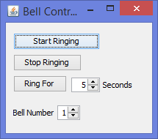
This option (C) was intended to allow you to ring the bells on command. I have no idea how this would be useful, but it looked like it would be easy to add. However, in my testing, it wasn't working correctly, and I haven't been able to get it to work since then. Feel free to play around with it, but unless you have a use in mind for it, it will probably never be a finished feature.

Other
- Close the clock controller application when it is not in use.
- If two or more people attempt to access the clock system at the same time (from different computers), the schedule may become corrupted.

Troubleshooting
If you cannot connect to the clock and have verified that:
- You are using the correct address and port number
- You are connected to the correct network
Then the clock network interface may need to be rebooted.
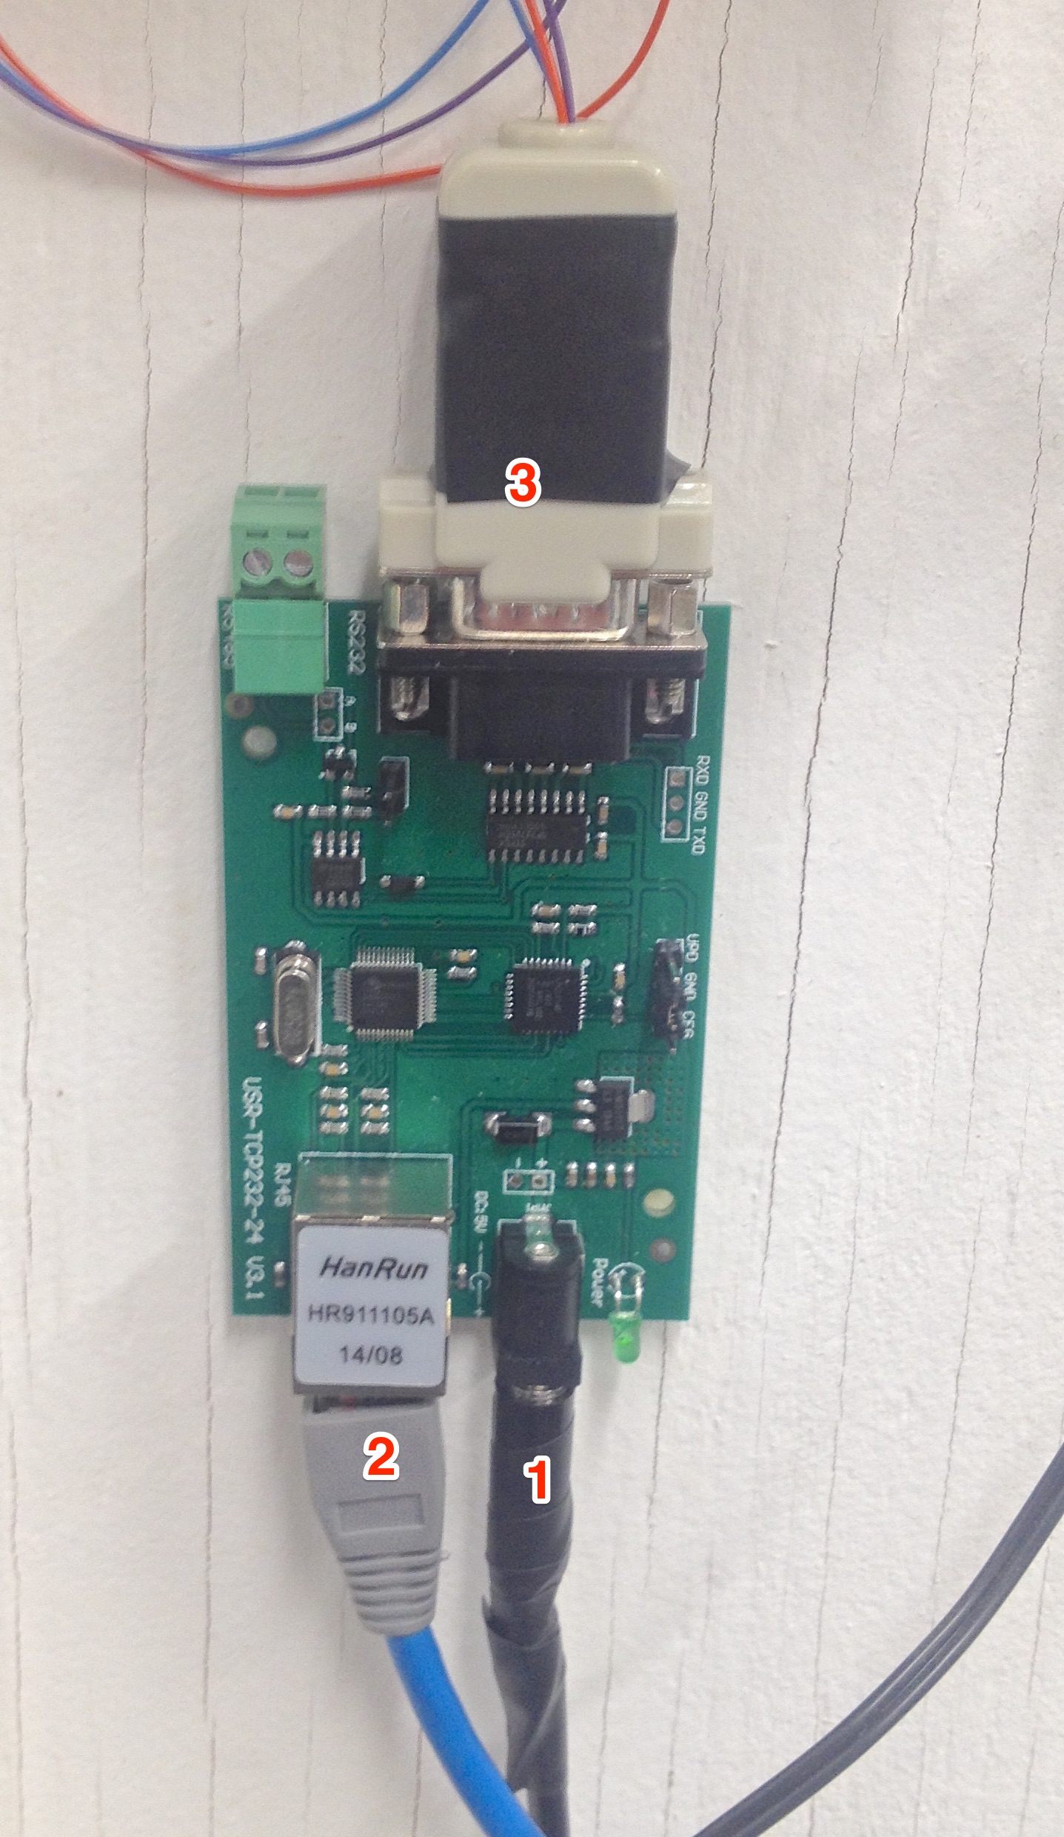
Locate the clock network interface hardware. Unplug the power connector (1) and wait 10 seconds, then plug it back in. Verify that the network connector (2) and serial connector (3) are attached tightly as well. Then try to connect to the system again.

